**Materials:**

* 1 Arduino Uno microcontroller
* 1 Adafruit Motor shield v2
* 4 3-6v dc motors with tiers and gearboxes[1]
* multi-colored wires
* 6 eBoost 5mm photoresistors
* 1 1N5822 diode
* 1 100Ωressistor
* 1 410Ω resistor
* 1 110Ω resistor
* 5 10KΩ resistors[2]
* 1 adjustable 3/6/9/12 volt solar panel
* 1 9v Energizer rechargeable battery
* 3 3x4.5in protoboards
* 2 2x1.5in protoboards
* 1 multimeter
* 1 soldering iron
* solder
* 1 drill
* sandpaper
* 2 11cmx24cm acrylic laser cut sheets
* 2 11cmx23cm acrylic laser cut sheets
* 1 24cmx23cm acrylic laser cut sheet
* 1 Styrofoam board slightly larger than 24cmx23cm
* 1 felt sheet slightly smaller than 24cmx23cm
* 1 hot glue gun
* 2 Watt’s UPs
* 2 power supplies for the Watt’s Ups
* Set of Jumper wires.
* 1 wire stipper

**Procedure:**

**Building the robot:**

All of the steps up through setting up the frame step 7 and the wiring of the protoboard as seen in the wiring diagram were performed over the course of the 2017-2018 school year.(Wiring of the protoboard seen in wiring steps not included)

**Wiring the protoboard:**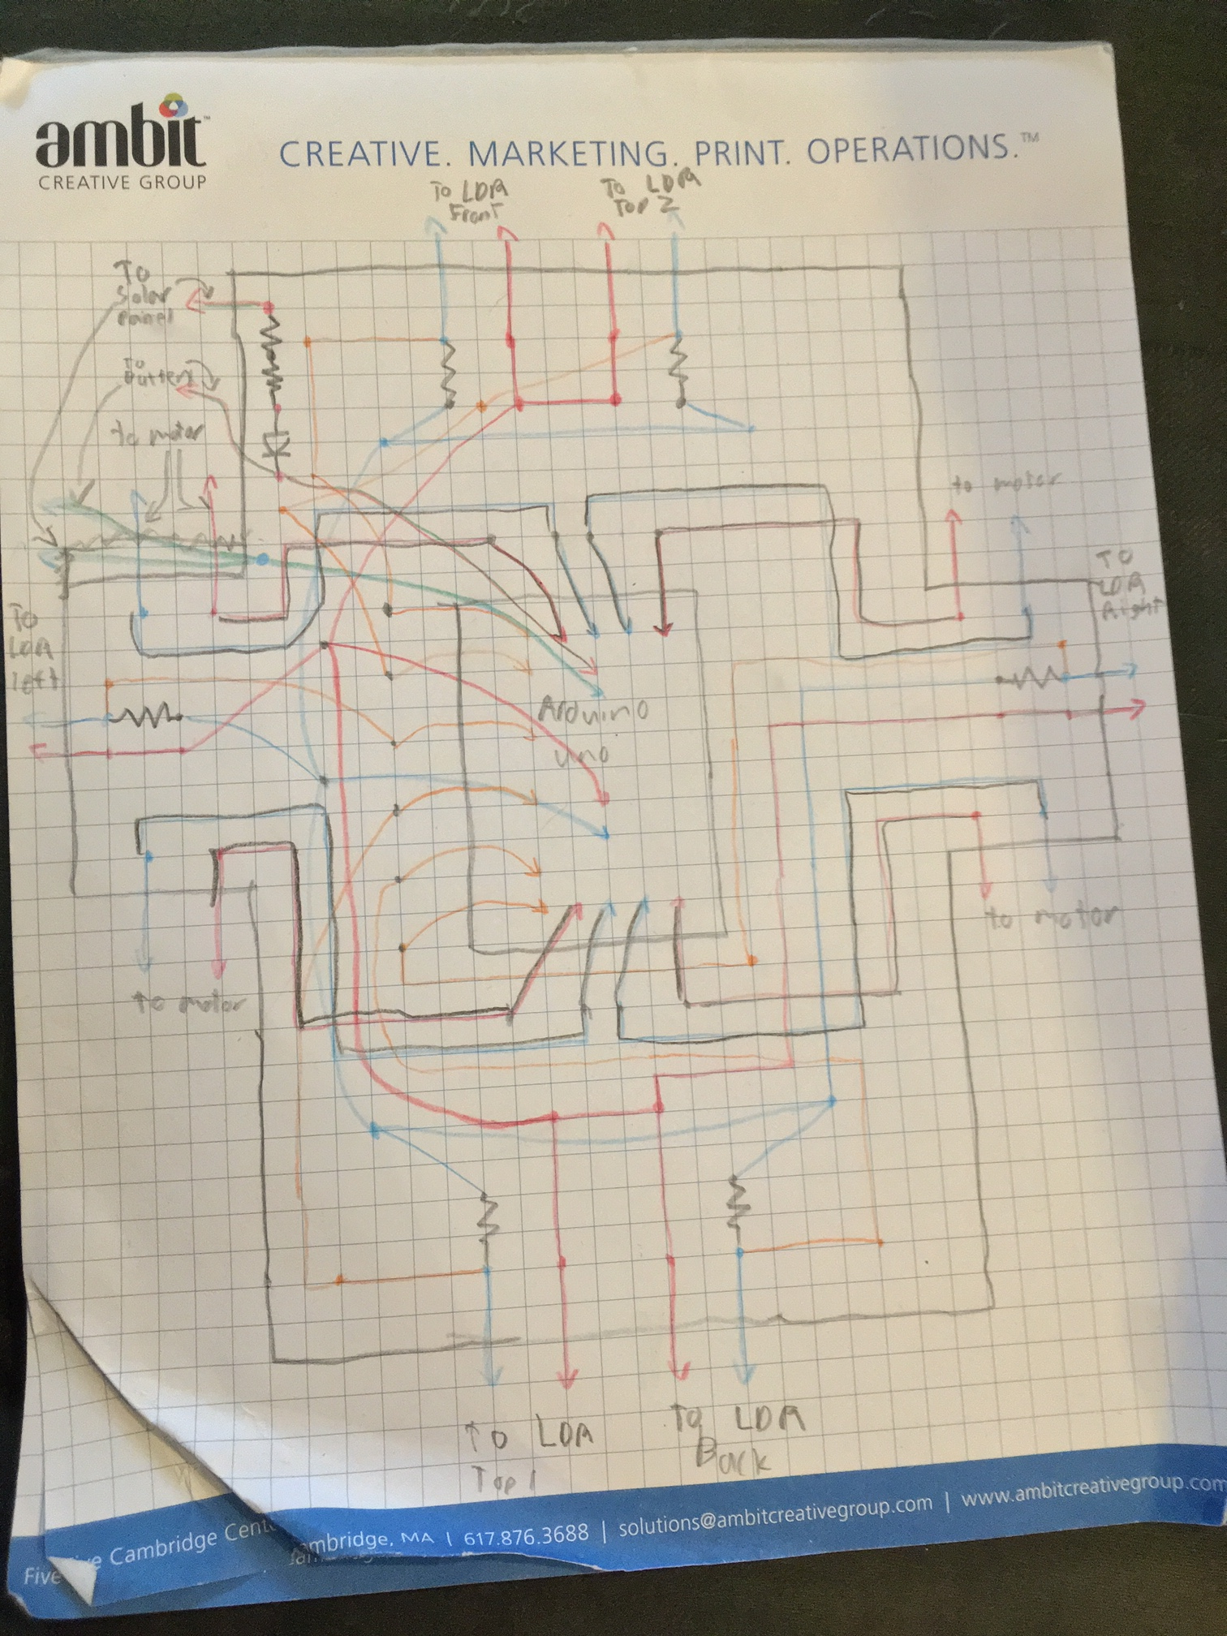

The protoboard is wired as shown above with the wires running along the non-conductive side of the board and the end of the wires threaded through the holes and soldered together onto the conductive rings on the conductive side. Each dot represents the connecting of 2 or more wires/components by soldering. The arrows represent connecting to a component like a motor, or Arduino. The squiggly line represents a resistor. The triangle pointing to a perpendicular line represents a diode. All of the resistors connecting to LDR’s are 10k ohms, except the one going to “LDR back” which is a 110 ohm. It is supposed to be a 10k but the wrong resistor was put on. This can be corrected for in the coding or replaced at a later date. The two resistors going into the diode are a 100 ohm and a 410 ohm. See the materials list to see what the diode is. The diagram is not to scale and the location of some wires relative to others is slightly off. I.e. Some wires might run to the left of another wire in the diagram but on the actual board run on the right.

(Diagram does not show Watts up wiring and modifications made while working on project. See wiring section of procedure to see where the watts ups are connected and other modifications).

**Planning:**

1. On wednesday (1-30-2019) go through the list of components needed and find out what components still need to be acquired
2. On Thursday (1-31-2019) identify how to obtain these components and order any that need to be ordered online.
3. On Thursday (1-31-2019) or if needed Friday (2-1-2019) clear workspace.
4. On Saturday (2-2-2019) go to the store to buy any components not ordered online.

**Setting up the frame:**

1. Using Elmer’s glue the felt sheet to the top of the Styrofoam board.
2. Hot glue the 4 motors to each corner of the underside of the Styrofoam board with the wheels running parallel to each other.
3. Attach the wheels to the motors.
4. Locate and mark each sections of the acrylic sheets that holes are drilled into in steps 5-7 with a marker and then scuff up those sections with sandpaper
5. Drill 2 small holes in both of the 23cmx11cm acrylic sheets that line up with the wires sticking out of the short sides of the protoboard.
6. Drill 3 small holes in one of the 24cmx11cm acrylic sheets that line up with the wires sticking out of the protoboard on the long side without the diode.
7. Drill 6 small holes in one of the 24cmx11cm acrylic sheets that line up with the wires sticking out of the protoboard on the long side with the diode.
8. Using acrylic cement, connect the acrylic sheets to form a floorless box 24cm long, 23cm wide, and 11cm tall.
9. Hot glue one side of velcro to the 9v rechargeable battery and the other corresponding section of velcro to the felt on the Styrofoam board. Then place the battery on the board.
10. Place protoboard on the felt.
11. Hot Glue the 2 watts ups to the styrofoam board.
12. Hot glue one side of velcro to each of the watts up’s power supplies and the corresponding sides to the styrofoam board. Then place the watts up’s power supplies to the board.
13. Place the acrylic box on top of the Styrofoam board with the holes lining up to the corresponding sides.
14. Secure the solar panel onto the top of the box using velcro.
15. (do after finishing wiring steps) Using hot glue, secure one photoresistor to each of the non top sides with the ends sticking through the wire holes.
16. (do after finishing wiring steps) Hot glue 2 photoresistors to the top of the acrylic box with each close to the front and back of the robots respectively. Glue the wires to the acrylic running down towards the holes on the front and back of the acrylic box.

**Wiring:**

1. Remove the box housing.
2. Desolder the diode and flip it’s orientation.
3. Solder male jumper wires to the ends of outgoing wires and female jumper wires to any incoming wires.(use the box to make sure wires are long enough)
4. Slide heat shrink tubing over all internal exposed wire possible and shrink the wire with a heat gun.
5. Cover all exposed wire not heat shrinkable with electrical tape.
6. Add a new positive in wire to protoboard connected to the right positive of watts up 2.
7. Connect the old positive in to a junction with the left positive wire of watts up 2 and another wire.
8. Solder a female jumper wire to the battery’s positive wire and a male jumper wire to the junction created in step 7.(plug these 2 in to turn on robot)
9. Solder wires to ends of Watts Ups left negative and form a junction with a jumper wire going to the ground junction.
10. Connect the left positive wire from watts up 1 to a male jumper wire going to the positive wire on the solar panel
11. Connect the right positive wire from watts up 1 to the positive solar panel input on the protoboard.
12. Use a multimeter to test for faulty wiring.
13. Put box back on.
14. Pull the wires through the corresponding holes using tweezers.
15. Attach the corresponding jumper wires together.

Test robot to make sure it works and troubleshoot issues.

**Testing**

1: time vs distance(speed trial)

Purpose:To find out how long the robot would take to travel a certain distance while running the sunseeking code.

Procedure:

Set 2 parallel pieces of painters tape 5 ft apart on the floor. Set the robot down with it’s wheels right behind the tape. Plug in the robot and have it run the speed trial function. The speed trial function goes: forward twice, turns on the spot left, turns on the spot back to center, goes backwards once, and finally forwards 6 times. This is repeated twice with exactly 10 seconds to reset the robot. The turning, going backwards, and 10 second break simulate the robot’s imperfect movement pattern.

2: power usage when moving

Purpose: To see how much power is being used when moving which with data from the speed trial allows calculations to see how much energy it takes to go a certain distance.

Procedure:

Set the robot on a stand to prevent the wheels from touch the ground. Attach alligator clips to a multimeter. Connect the other end of the positive alligator clip to the jumper cable connection that turns on the robot. Connect the other end of the negative alligator clip to the jumper cable that goes to the solar panel’s negative wire. Set the multimeter to the voltage settings. Have the arduino run the speed trial function. Record the voltage when the motors are running. Detach the alligator clips from the robot and reattach one to each of the jumpers that turn on the robot when connected. Set the multimeter to amperage. Record the amperage when the motors are running.

3: solar power generation in different sunlight

Purpose: see how much power the solar panel can generate in direct and indirect sunlight. This data with the other data allows calculations that determine at what point is it worth it to move to better sunlight.

Procedure:

Attach the positive and negative alligator clips from the solar panel to the opposite ends of a 124 ohm resistor. Use the multimeter to record the voltage. Detach one of the solar panel’s alligator clips and place one of the multimeters prongs on the detached alligator clip and the other prong where the clip was detached from. Record the amperage.

(Unfishished)

1. <https://www.amazon.com/gp/product/B012FYMW54/ref=oh_aui_detailpage_o04_s01?ie=UTF8&psc=1>
2. the 110 should be a 10k but was put on by accident but it can be corrected for in the coding or removed.